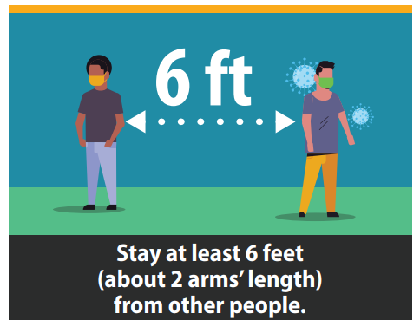

Thank You for Practicing   
Social Distancing

For information about virtual services,   
please call (XXX) XXX-XXXX